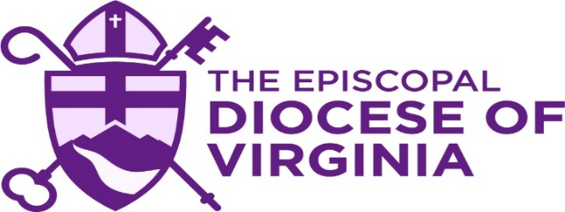

Diocesan required Safe Church, Safe Communities Training modules
based on your ministry role.

Listed below are the Safe Church, Safe Communities Training Classes for Clergy – Bishops, Priests, Deacons and Postulants:

- Safe Church, Safe Communities – Universal Training: Introduction & Theological Background
- Safe Church, Safe Communities – Universal Training: Organizational Rule and Policies
- Safe Church, Safe Communities – Universal Training: Healthy Boundaries
- Safe Church, Safe Communities – Specialty Training: Power and Relationships
- Safe Church, Safe Communities – Specialty Training: Abuse and Neglect
- Safe Church, Safe Communities – Universal Training: Inclusion
- Safe Church, Safe Communities – Specialty Training: Pastoral Relationships
- Safeguarding God’s People: Preventing Sexual Harassment for Managers & Supervisors
- Safe Church, Safe Communities – Specialty Training: Bullying

Listed below are the Safe Church, Safe Communities Training Classes for Staff and Eucharistic Workers:

- Safe Church, Safe Communities – Universal Training: Introduction & Theological Background
- Safe Church, Safe Communities – Universal Training: Organizational Rule and Policies
- Safe Church, Safe Communities – Universal Training: Healthy Boundaries
- Safe Church, Safe Communities – Specialty Training: Power and Relationships
- Safe Church, Safe Communities – Specialty Training: Abuse and Neglect
- Safe Church, Safe Communities – Universal Training: Inclusion
- Safe Church, Safe Communities – Specialty Training: Pastoral Relationships
- Safeguarding God’s People: Preventing Sexual Harassment for Workers
- Safe Church, Safe Communities – Specialty Training: Bullying

Listed below are the Safe Church, Safe Communities Training Classes for Vestry Members and Wardens:

- Safe Church, Safe Communities – Universal Training: Introduction & Theological Background
- Safe Church, Safe Communities – Universal Training: Organizational Rule and Policies
- Safe Church, Safe Communities – Universal Training: Healthy Boundaries
- Safe Church, Safe Communities – Specialty Training: Power and Relationships
- Safe Church, Safe Communities – Specialty Training: Abuse and Neglect
- Safe Church, Safe Communities – Universal Training: Inclusion
- Safe Church, Safe Communities – Specialty Training: Pastoral Relationships
- Safeguarding God’s People: Preventing Sexual Harassment for Workers
- Safe Church, Safe Communities – Specialty Training: Bullying

Listed below are the Safe Church, Safe Communities Training Classes for Sunday School Teacher, Children’s and Youth Ministry:

- Safe Church, Safe Communities – Universal Training: Introduction & Theological Background
- Safe Church, Safe Communities – Universal Training: Organizational Rule and Policies
- Safe Church, Safe Communities – Universal Training: Healthy Boundaries
- Safe Church, Safe Communities – Specialty Training: Power and Relationships
- Safe Church, Safe Communities – Specialty Training: Abuse and Neglect
- Safe Church, Safe Communities – Universal Training: Inclusion
- Safe Church, Safe Communities – Specialty Training: Pastoral Relationships
- Safeguarding God’s People: Preventing Sexual Harassment for Workers
- Safe Church, Safe Communities – Specialty Training: Bullying

